KDM Lab1

ER-Diagram:

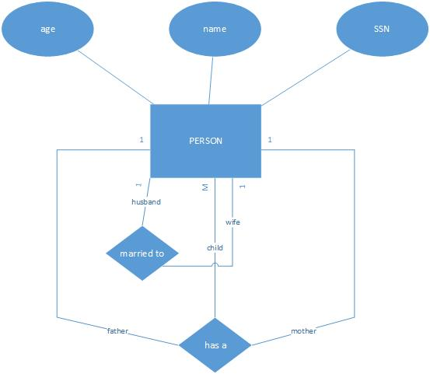

Class Diagram of Family domain:

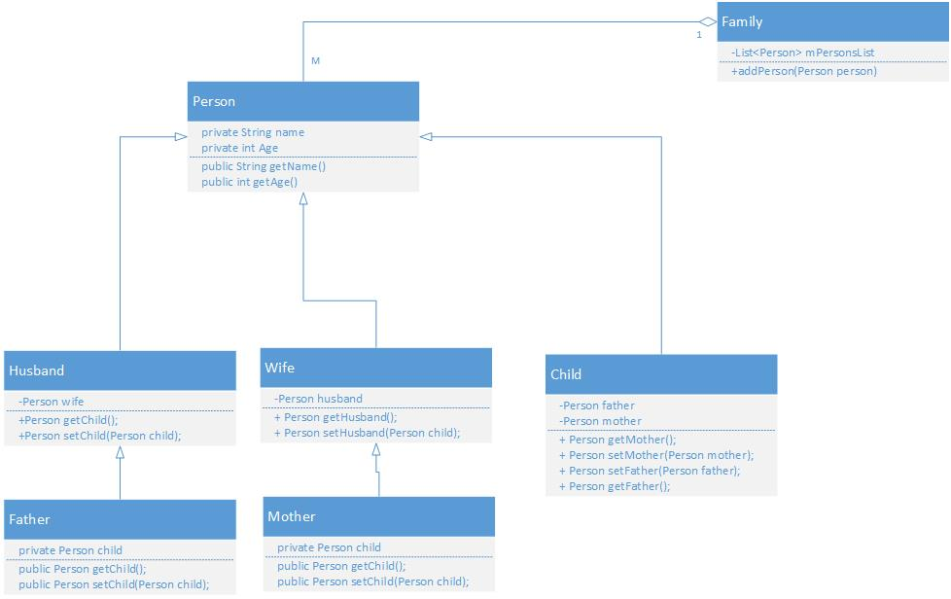

GitHub: